* **Subgrafo 1: Google maps** [**link**](https://www.google.com.br/maps/place/23%C2%B032'56.7%22S+46%C2%B039'16.5%22W/@-23.5482475,-46.6543735,15.44z/data=!4m4!3m3!8m2!3d-23.5490903!4d-46.6545895?entry=ttu)

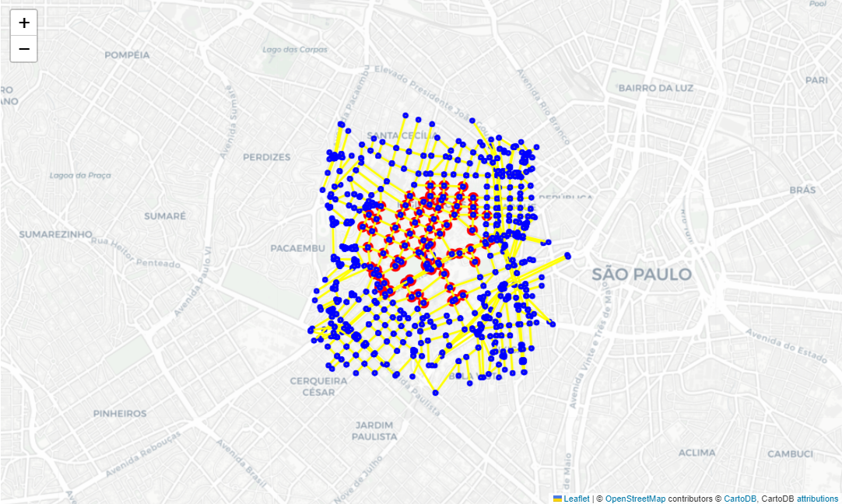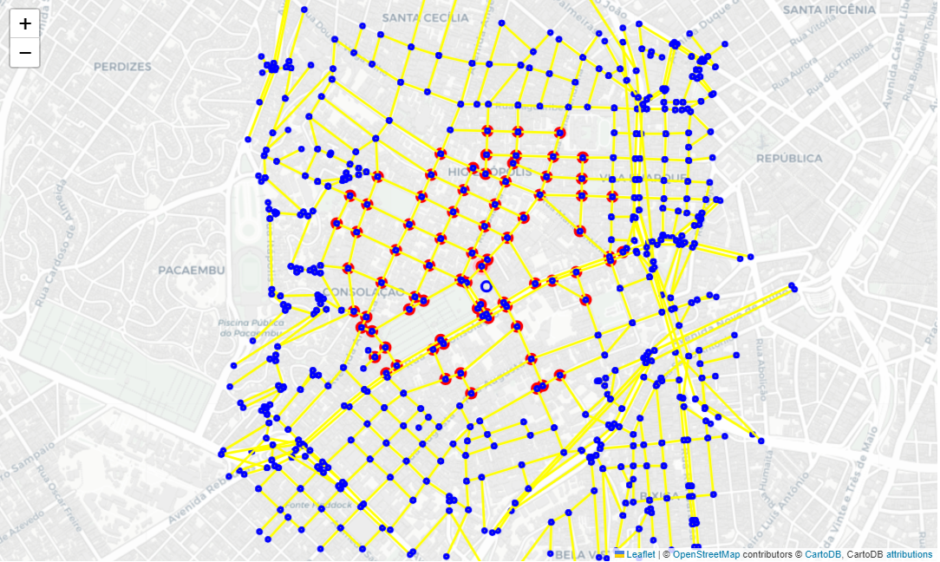

* **Subgrafo 2: Google maps** [**link**](https://www.google.com.br/maps/place/23%C2%B032'56.7%22S+46%C2%B038'45.2%22W/@-23.5490903,-46.6484703,17z/data=!3m1!4b1!4m4!3m3!8m2!3d-23.5490903!4d-46.6458954?entry=ttu)

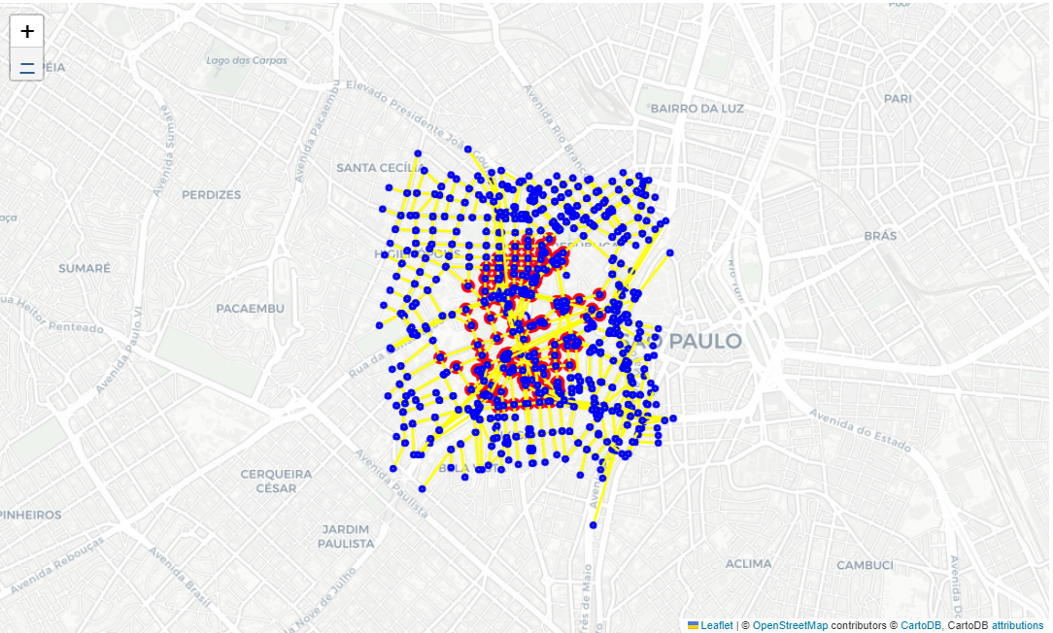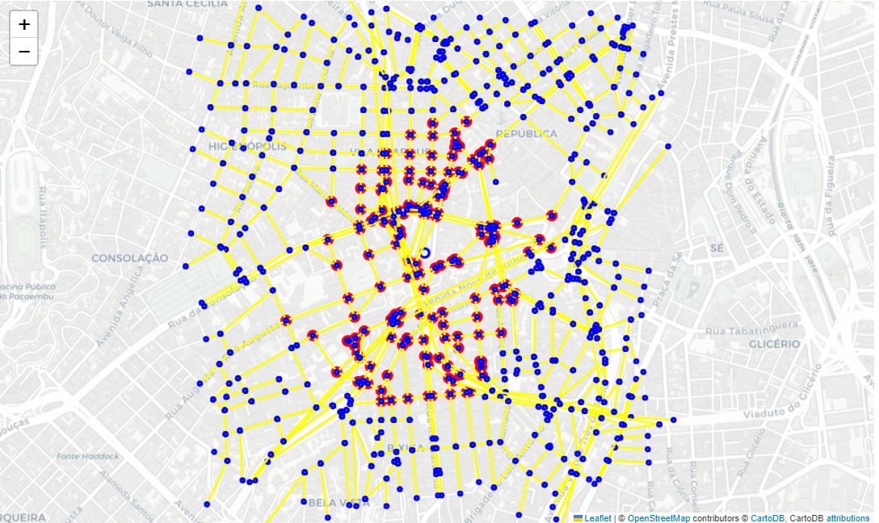

* **Subgrafo 3: Google maps** [**link**](https://www.google.com.br/maps/place/23%C2%B036'32.7%22S+46%C2%B041'40.5%22W/@-23.6090903,-46.6971644,17z/data=!3m1!4b1!4m4!3m3!8m2!3d-23.6090903!4d-46.6945895?entry=ttu)

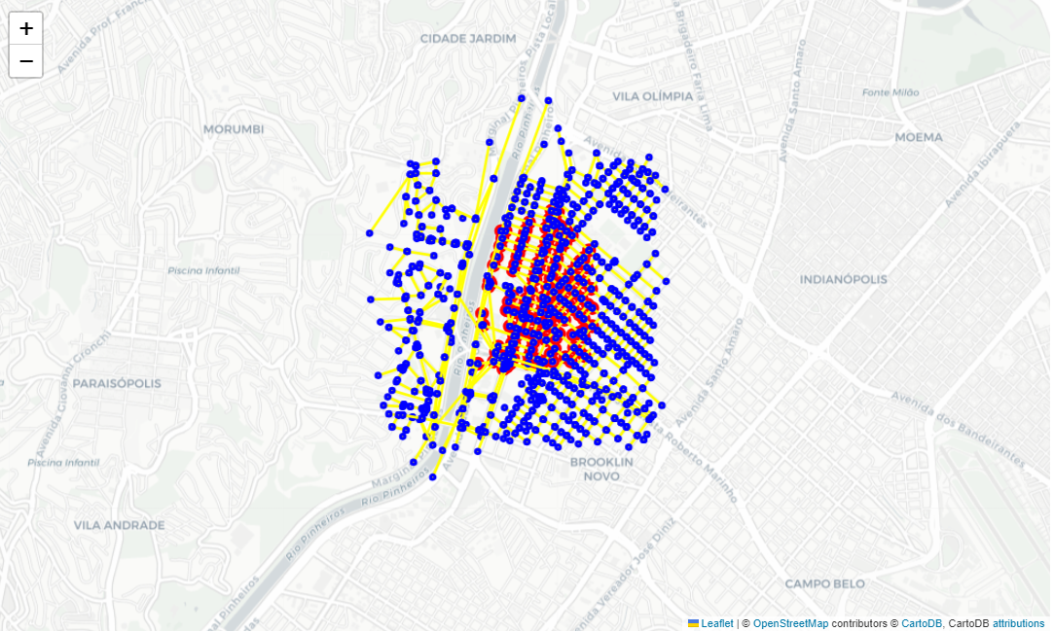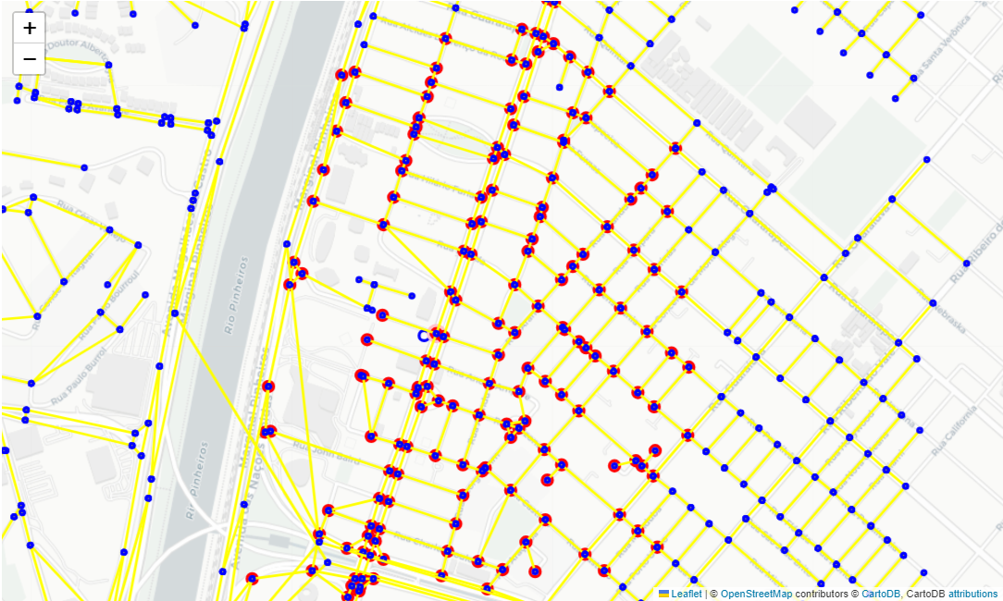

* **Subgrafo 4: Google maps** [**link**](https://www.google.com.br/maps/place/23%C2%B030'25.5%22S+46%C2%B035'45.2%22W/@-23.5070903,-46.5984703,17z/data=!3m1!4b1!4m4!3m3!8m2!3d-23.5070903!4d-46.5958954?entry=ttu)

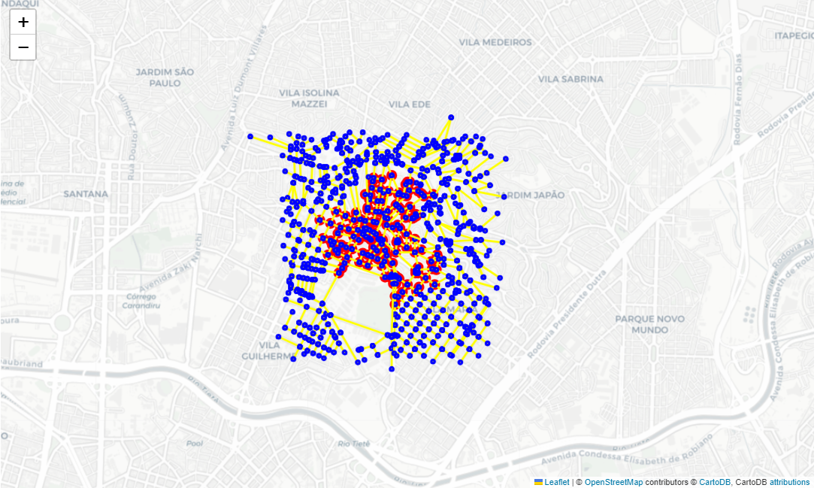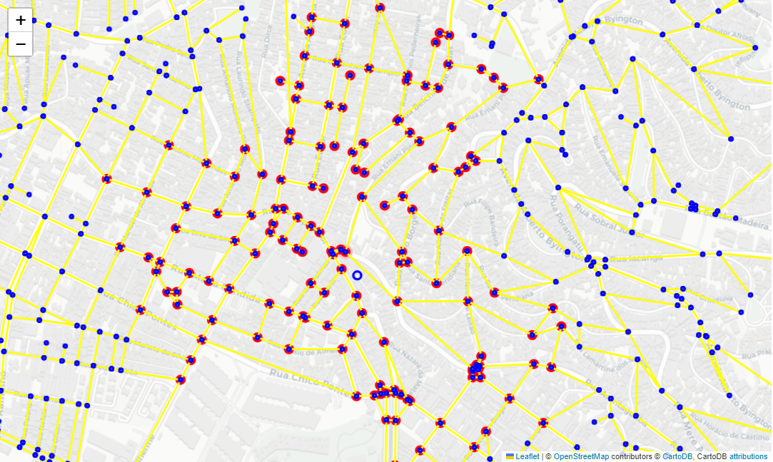

* **Subgrafo 5: Google maps** [**link**](https://www.google.com.br/maps/place/23%C2%B035'34.4%22S+46%C2%B039'21.6%22W/@-23.592892,-46.6585759,17z/data=!3m1!4b1!4m4!3m3!8m2!3d-23.592892!4d-46.656001?entry=ttu)

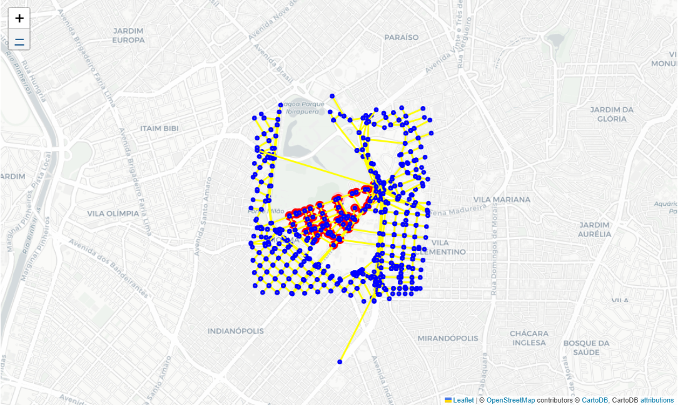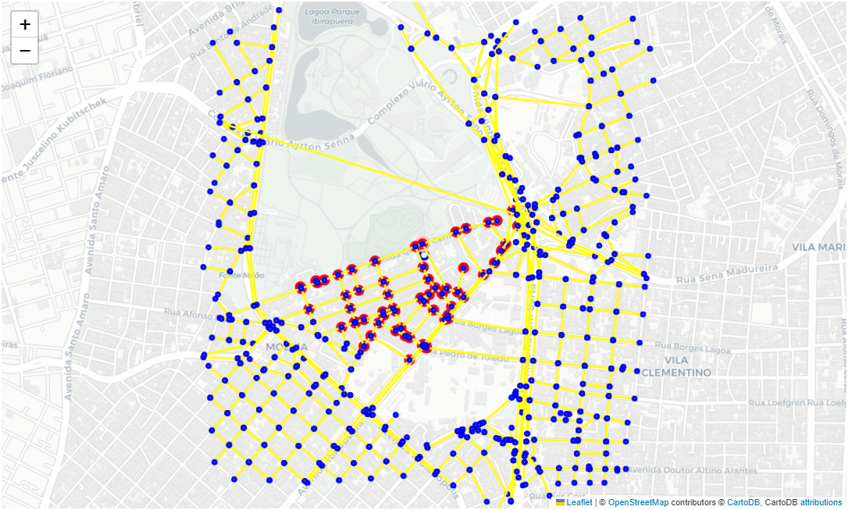

* **Subgrafo 52: Google maps** [**link**](https://www.google.com.br/maps/place/23%C2%B035'51.2%22S+46%C2%B039'18.1%22W/@-23.59756,-46.6576059,17z/data=!3m1!4b1!4m4!3m3!8m2!3d-23.59756!4d-46.655031?entry=ttu)

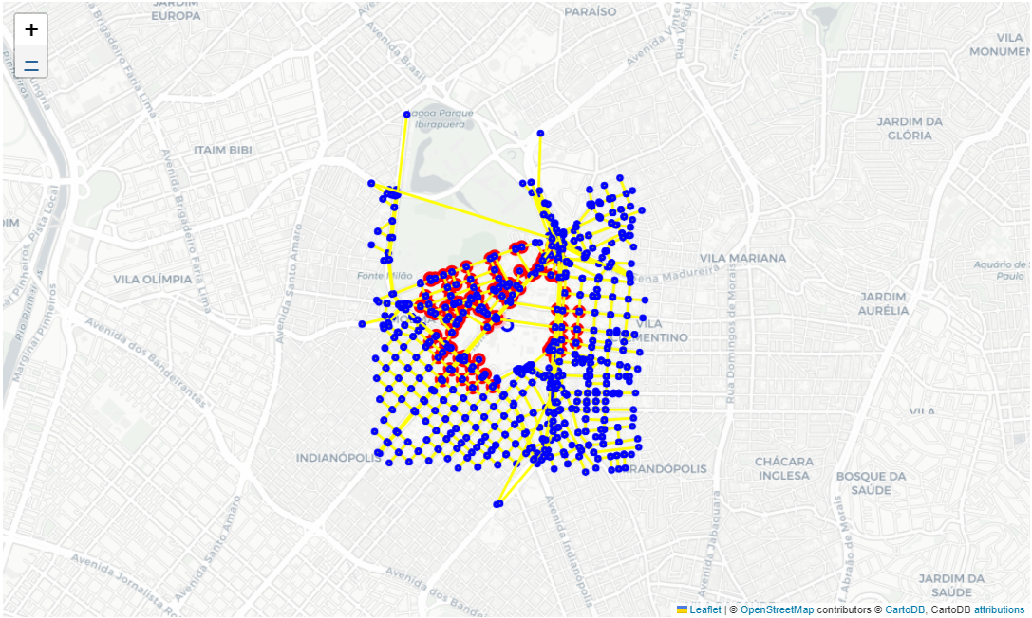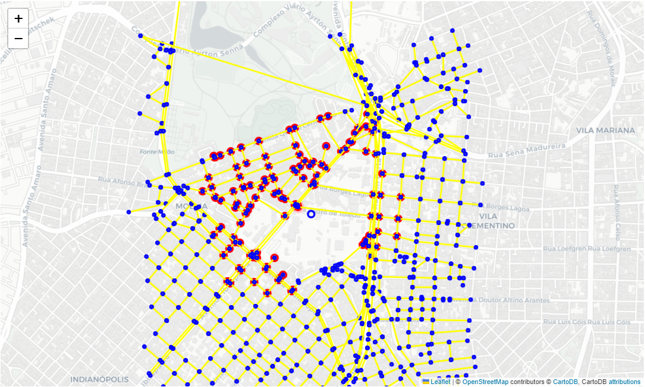

* **Subgrafo 6: Google maps** [**link**](https://www.google.com.br/maps/place/23%C2%B033'39.2%22S+46%C2%B039'25.6%22W/@-23.560901,-46.6596859,17z/data=!3m1!4b1!4m4!3m3!8m2!3d-23.560901!4d-46.657111?entry=ttu)

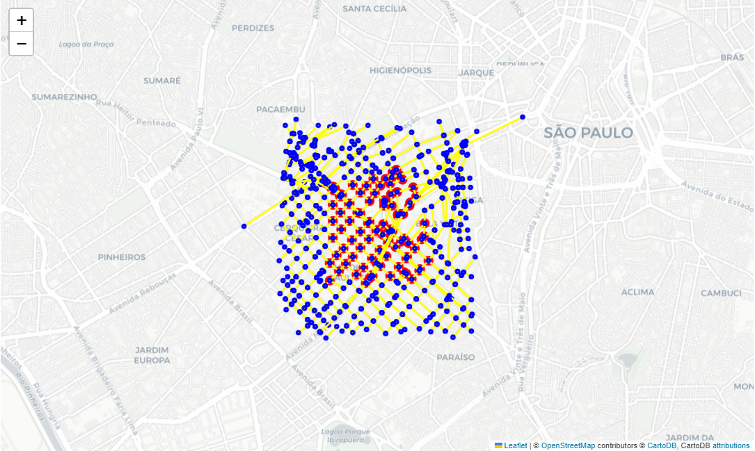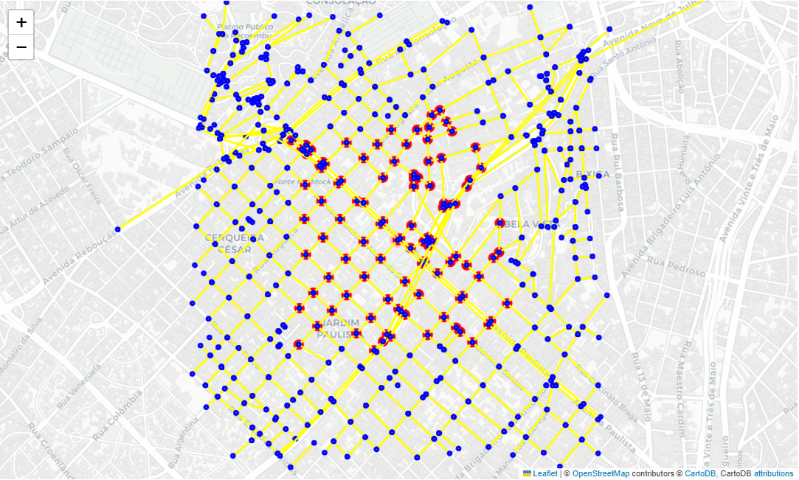

* **Subgrafo 7: Google maps** [**link**](https://www.google.com.br/maps/place/23%C2%B032'42.2%22S+46%C2%B042'12.9%22W/@-23.545043,-46.7061669,17z/data=!3m1!4b1!4m4!3m3!8m2!3d-23.545043!4d-46.703592?entry=ttu)

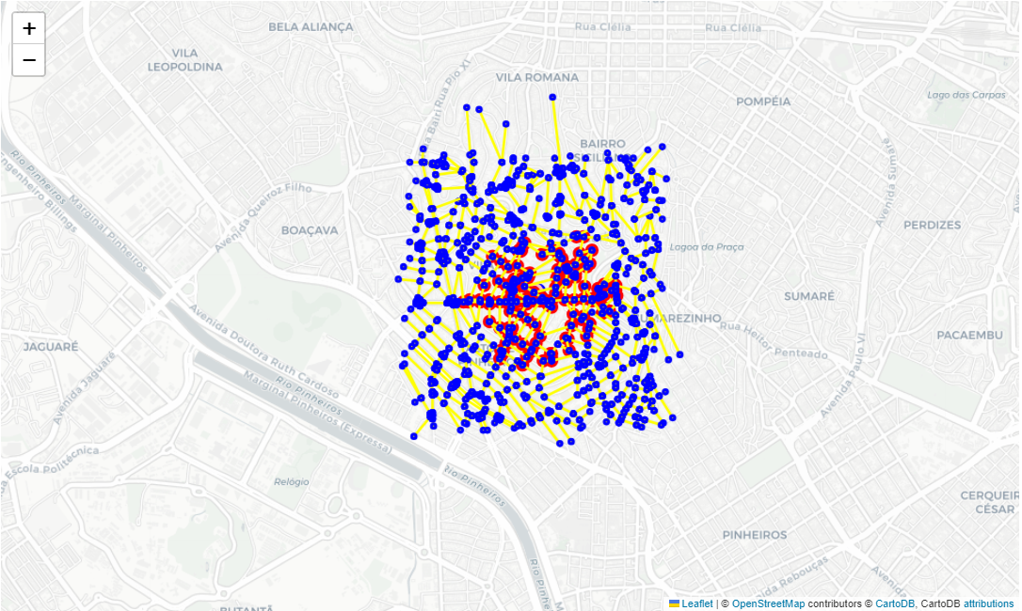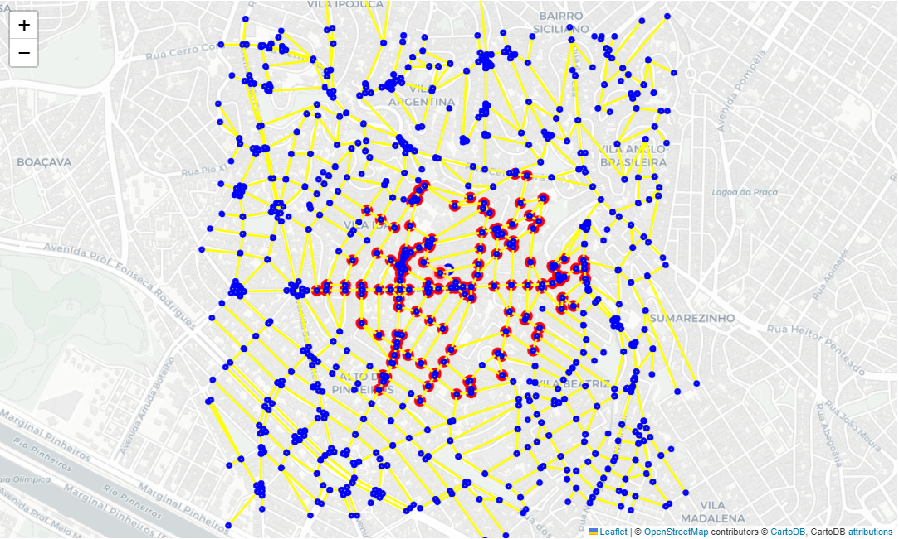

* **Subgrafo 8: Google maps** [**link**](https://www.google.com.br/maps/place/23%C2%B030'58.1%22S+46%C2%B037'31.0%22W/@-23.516127,-46.6278559,17z/data=!4m4!3m3!8m2!3d-23.516127!4d-46.625281?entry=ttu)

